5. Answer the following questions.
a. How does the earth move around the sun?
-The earth revolves around the Sun in a path called an elliptical orbit.
b. What are the causes of changes of seasons?
-The two main causes of changes orf seasons are
1.the Earth’s tilted axis
2.Its revolution around the Sun.
c. Draw a chart to show the changes of seasons and describe the condition of each season.
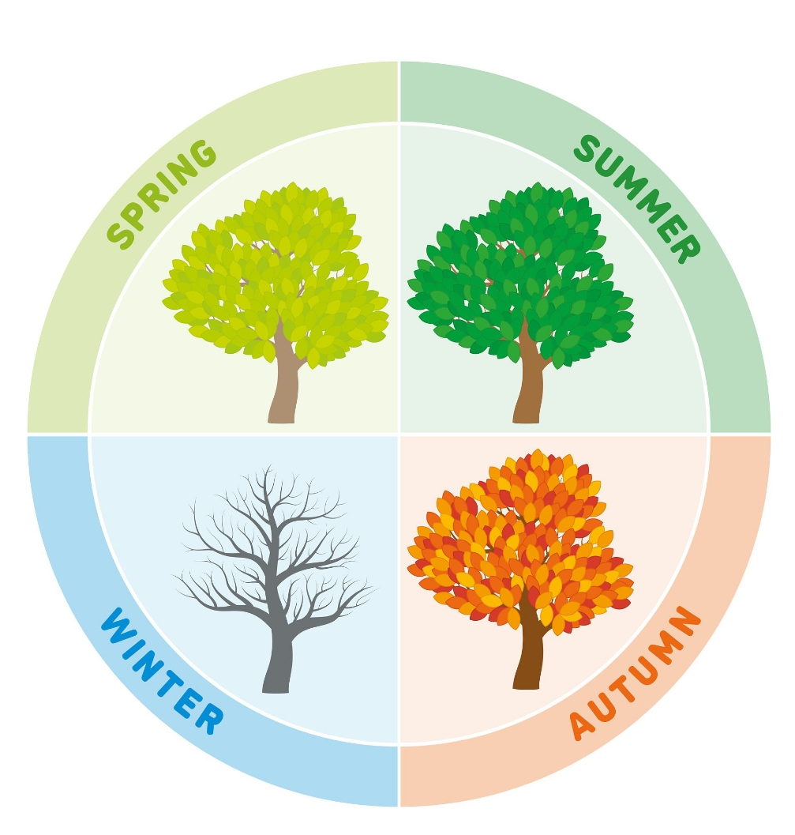
-Summer are hottest season whereas days are long and nights are short.
-Autumn has cool weather whereas days and nights are nearly equal and leaves change color.
-Winter have coldest season whereas days are short and nights are long.
-Spring have weather whereas days and nights are nearly equal and new plants begin to grow.
d. Mark the seasons in all the positions in the diagram below.
* E_1 (North Pole tilted towards Sun): Summer
* E_2 (Transition from Summer to Winter): Autumn
* E_3 (North Pole tilted away from Sun): Winter
* E_4 (Transition from Winter to Summer): Spring
e. What is the solar system?
-The group of different heavenly bodies that revolve around the sun and the sun itself is called solar system.
f. What are the size and the temperature of the sun?
- The size of the sun is 1.4 million kilometers and the temperature of the sun is 6000 degree Celsius at Surface and 15 million degree Celsius at the core .
g. How does the sun produce heat?
-The Sun produces heat and light when hydrogen atoms combine to form helium.
h. What is a satellite?
-A satellite is an object that orbits a larger object in space.
i.What is a comet? When does it appear in the sky?
-A comet is a small, icy body that revolve around the Sun. It appears in the sky when it is closest to the Sun and its bright tail is visible from Earth.
j. Why do the meteorites not appear during the day time?
-The meteorites do not appear during the day because the light coming from sun is powerful than that of metrotite.
k. Identify the following and write any two characteristics of these objects.
(i) Comet:
1. It is made of ice, dust, and rock.
2. It forms a bright tail when near the Sun.
(ii) Moon:
1. It is Earth’s only natural satellite.
2. Its surface has many craters.
l. Is the moon the same day every day? Why?
-No, the moon is not the same every because the part that reflects the light of the sun is only seen.
m. When does the whole moon appear?
-The whole moon appears during the Full moon .
n. Name the six main phases of the moon with figures.
-The six main phases are: New Moon, Crescent Moon, First Quarter, Gibbous Moon, Full Moon, and Last Quarter.

